More About Our Speaker
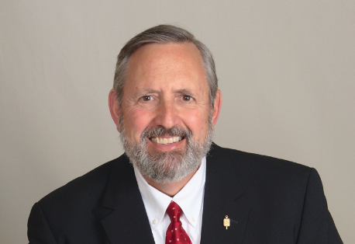

Michael Koscielny

MBA, CPCU, CIC, ITP,

Chief Executive and Founder

Born2Lead, LLC
BIO
Michael Koscielny

“The Art of Ethical Negotiations”
As insurance professionals we commit to live by a high standard of ethics. We reaffirm that commitment every day in the work we do. The art of negotiating is a skill used by many insurance professionals. Balancing the tenets of effective negotiating skills along with high ethical standards ensures that those outcomes truly benefit both parties. Most roles in our industry require us to negotiate, from new business guidelines and pricing, renewal terms, loss settlement of claims, resolution of lawsuits and finally third-party vendors who provide us with a multitude of resources. This presentation will identify what ethical interactions are required for all parties and contrast that with time proven negotiating skills, to ensure that the highest standards of professional conduct are met in every interaction.

Michael Koscielny, MBA, CPCU, CIC, ITP, ARe, AIC, API, AIS, AINS, is chief executive officer and founder of Born2Lead, LLC. He has more than 40 years of experience creating effective teams and innovative processes for underwriting and pricing for various insurance companies.

Born2Lead, LLC’s goal is to develop and mentor emerging leaders in every industry for roles of greater responsibility. Sharing leadership skills that have a proven track record for success in group and personal settings helps young professionals bridge the gap as they prepare themselves not only technically but as future leaders. Born2Lead, LLC offers workshops on leadership skills development, setting professional/career goals, active listening skills for success, and for mentors, becoming allies, advocates, and champions, among many other sessions tailored to the needs of those young leaders.

Mike currently serves as Director of Marketing for Graduate Programs for The University of Olivet. He is an instructor for The National Alliance CISR and CIC designations and a Facilitated CPCU Study Group Leader for The Institutes. He also serves as the 2023-2024 President of the Society of Insurance Trainers and Educators. Mike was recently recognized by the Society of Insurance Trainers and Educators with Insurance Training Professional (ITP) for his work in creating a delivering educational content. The ITP is recognized by A.M. Best’s Professional Designations.

Mike has held many roles for The Institutes CPCU Society, including 2017 global president of the CPCU Society Leadership Council, 2017-2018 President of the Underwriting Executives Council and 2023-2024 President of the Society of Insurance Trainers and Educators. He lives in suburban Chicago with his wife, Deborah, and dogs, Wiley, and Teddy. He has written numerous articles and given many presentations.

